In **Playwright**, when your test fails, it **automatically captures screenshots, videos, and traces** to help you **debug easily.**

**Where are they stored?**

After running:

npx playwright test

A folder called **test-results/** is created.

Inside that, you'll find:

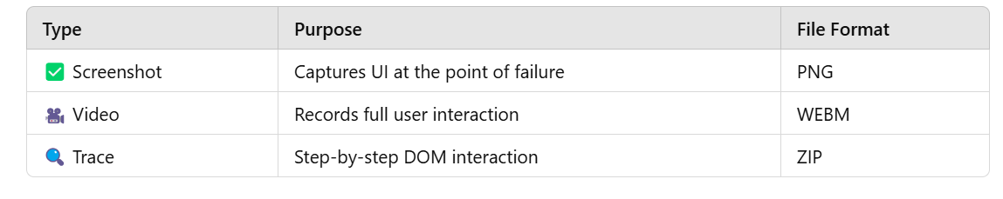

**🌟 How to View the Trace?**

npx playwright show-trace test-results/<your-test-folder>/trace.zip

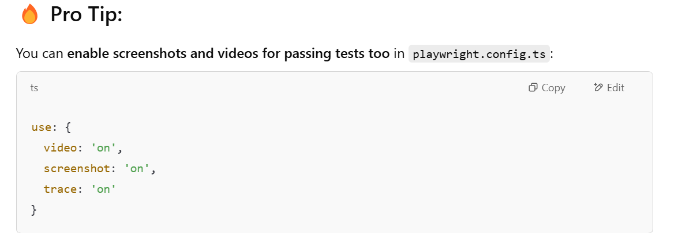Your Failed Test Already Has:

test-results\user-grid-should-display-4x4-user-grid-chromium\video.webm

run

npx playwright show-trace test-results/user-grid-should-display-4x4-user-grid-chromium/trace.zip

**This will:**

* Open a **visual UI in your browser**
* Show **step-by-step screenshots**
* Show **network requests**
* Show **console logs**
* Even **time taken per step**

**Pro Tip:**

If your test failed in **Firefox or Webkit**, you can open their traces too:

npx playwright show-trace test-results/user-grid-should-display-4x4-user-grid-firefox/trace.zip

Yes, **Cypress also supports screenshots**, similar to Playwright.

**📸 Cypress Screenshot Features:**

* Cypress automatically captures screenshots **on test failure**.
* You can also **manually capture screenshots** at any point in your test using:

cy.screenshot('custom-screenshot-name');

**By Default:**

* Screenshots are saved in the **cypress/screenshots** folder.
* Screenshots can be taken **before or after an assertion**, or when the test fails.

**📸 Playwright Screenshot Features:**

* Playwright allows **more flexibility**, including capturing screenshots of:
  + **Full page**
  + **Specific elements**
  + **Viewport only**

await page.screenshot({ path: 'example.png' });

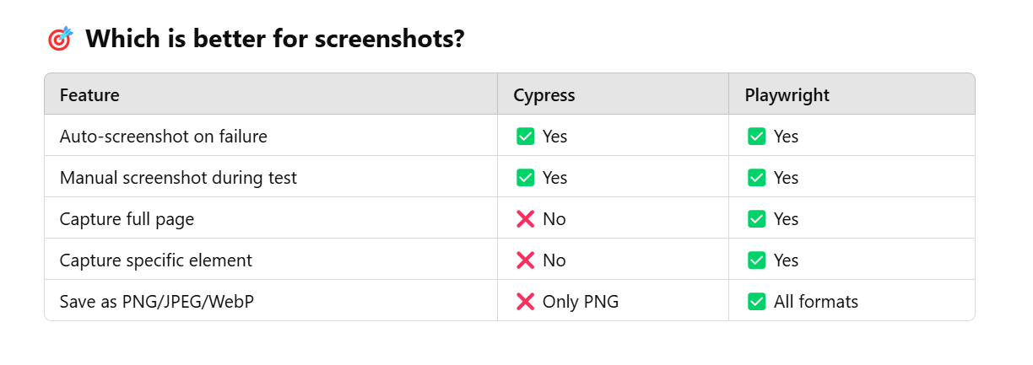

**Conclusion:**

* Cypress is good for **basic screenshot needs**.
* Playwright is better for **advanced use cases**, like **full-page snapshots** and **element-level screenshots**.

npx playwright show-trace

